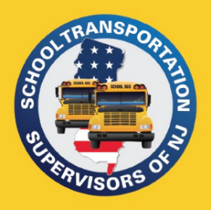
PO Box 66
Raritan, NJ 08869
908-252-1991
admin@njsts.org
www.njsts.org

Northern Region Meeting
DRTRS Training
Speaker:
Sue Spence
Senior Transportation Specialist (NJDOE)

Date: Friday, September 29, 2023
Time: 10:00 AM - 11:00 AM
Location: Zoom Link to be emailed

No Cost
Registration is Required – Please register by September 27th
Please email registration to John Aymil at jaymil@rtnj.org

Name: _____________________________________________________________________________________

School District or Company: ____________________________________________________________________

Telephone Number: _________________________ Email Address: ____________________________________

