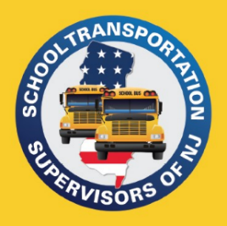
PO Box 66
Raritan, NJ 08869
908-252-1991
admin@njsts.org
www.njsts.org

Southern Region Meeting
DRTRS Training

Speaker:
Sue Spence
Senior Transportation Specialist (NJDOE)
Date: October 18, 2023
Time: 10:00 A.M.
Location: Zoom link to be emailed

No Cost

Registration is Required - Please register by October 13th
Please email registration to: Sclair@franklintwpschools.org

Name:

School District or Company:

Telephone: Email Address:

