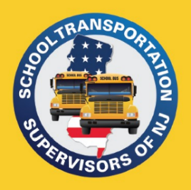
PO Box 66
Raritan, NJ 08869
908-252-1991
admin@njsts.org
www.njsts.org

Northern Region Meeting

Operation Lifesaver - Rail Safety Education

Speaker: Chip Greiner & Barbara Foran, NJDOT

Date: February 9, 2024
Time: 10 am - 11 am
Location: PDC Room Sparta BOE Office
Address: 18 Mohawk Ave
Sparta, NJ 07871

Cost: No Cost

Registration is Required

Please email registration to: June Macko at june.macko@sparta.org

Name:

School District or Company:

Telephone: Email Address:

