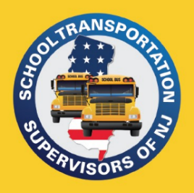
PO Box 66
Raritan, NJ 08869
908-252-1991
admin@njsts.org
www.njsts.org

Central Region Meeting
CDL Modernized Training
Speaker: Scott Lyons
CDL Mobile Compliance Unit, Supervisor

Date: Wednesday, April 17th
Time: 10:00 AM
Location:
Howell Community Enrichment Center (formerly Southard School)
115 Kent Road
Howell Township, NJ 07731

No Cost
Registration is Required – Click to register

Registration deadline is April 10th

All attendees MUST have a current CDL with P & S endorsements

Please bring a notepad, pen, and a highlighter with you. Handouts will be provided. Please wear comfortable clothing as we will be going outside as well.
Please email registration questions to Tara Vazquez at tvazquez@howell.k12.nj.us

