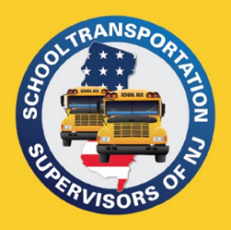
PO Box 66
Raritan, NJ 08869
908-252-1991
admin@njsts.org
www.njsts.org

Southern Region Meeting
DRTRS Training
Speaker:
Sue Spence
Senior Transportation Specialist (NJDOE)

Date: Thursday, September 25, 2025
Time: 10:00 AM - 11:00 AM
Location: Zoom Link to be emailed

No Cost
Registration is required – Please register by September 18TH.
Please email registrations to Heather Van Mater at vanmaterh@cinnaminson.com

Name: _____________________________________________________________________________________

School District or Company: ____________________________________________________________________

Telephone Number: _________________________ Email Address: ____________________________________

